Lab Exercise - Amazon SNS Notification for RDS Events (Web Console)

Objective
In this lab, you will:
- Configure an Amazon Web Services Amazon RDS database
- Create an Amazon SNS topic
- Subscribe to email notifications
- Enable RDS event notifications using SNS
- Receive alerts for database events

ARCHITECTURE
Amazon RDS → RDS Event Notifications → SNS Topic → Email Subscriber

STEP 1: Create SNS Topic
Go to AWS Console:
SNS → Topics → Create topic

Choose:
- Type: Standard
- Name: rds-alert-topic
Click Create topic

STEP 2: Create Email Subscription
Inside your SNS topic:
Click → Create subscription
- Protocol: Email
- Endpoint: your email (e.g. test@gmail.com)
Click Create subscription

IMPORTANT STEP
Go to your email inbox:
- Click Confirm subscription
Until you confirm → SNS will NOT send alerts.

STEP 3: Enable RDS Event Subscription
Go to:
RDS → Event subscriptions → Create subscription

Fill details:
- Name: rds-event-sub
- Target: SNS Topic
- SNS Topic: rds-alert-topic

Event categories (select these):
✔ Availability
✔ Failure
✔ Backup
✔ Recovery
✔ Configuration change

Select RDS instances:
- Choose your DB instance
Click Create

STEP 4: Test SNS Notification
Now trigger an event:
Option 1 (easy test):
- Reboot RDS instance
Go to:
RDS → Databases → Select DB → Reboot

Option 2:
- Modify instance class (small change)

STEP 5: Verify Email Alert
You should receive email like:
AWS RDS Notification
DB instance rebooted
DB instance: mydb
Region: ap-south-1
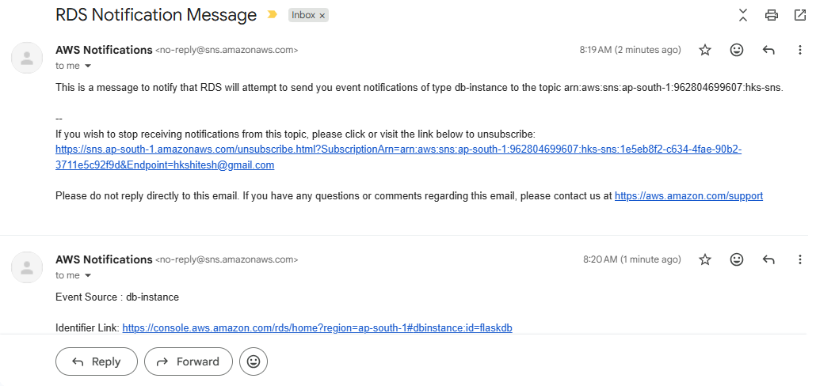

WHAT HAPPENED INTERNALLY
RDS Event (reboot/failure/backup)
↓
RDS Event Subscription
↓
SNS Topic (rds-alert-topic)
↓
Email notification sent

